Application for Services

FAMILY INFORMATION
Family Name: ______________________________________
Street Address: _____________________________________
City: _________________________ State: PA Zip: _______ County: __________
Length of time at this address: ____________
(If under 10 years answer next question)
States/Countries in which you have resided, in the last 10 years:________________________________
 | Applicant 1 | Applicant 2
First Name
Middle Name
Last Name
All Names/Aliases Used(if applicable)
Biological Sex Assigned at Birth | Female Male Inner Sex | Female Male Inner Sex
Gender Identity/Pronouns
Home Phone
Cell Phone
Work Phone
Email
Emergency Contact (Name & number)
Legal Marital Status | Single Married Divorced Widowed  Married living separately Other | Single Married Divorced Widowed  Married living separately Other
Date of Current Marriage (if applicable)

 | Applicant 1 | Applicant 2
Social Security Number
Date of Birth
Place of Birth (City, State, Country, etc.)
Citizenship Status
Highest Level of Education
Degree
Height
Weight
Religious Affiliation/Institution
Race & Ethnicity
Current Employer/Start Date/Position

Gross Monthly Income
Gross Annual Income

APPLICANT DISCLOSURE INFORMATION:
If your answer to any of the below questions is “Yes,” please provide a summary of the circumstances in the space provided.

General Social History/Functioning Questions: | Applicant 1 |  | Applicant 2
Have you ever been treated by a psychologist/therapist/counselor, etc.? | Yes | No | Yes | No
If “Yes” please provide additional information here:

Have you ever been prescribed medication for any mental health needs? | Yes | No | Yes | No
If “Yes” please provide additional information here:

Have you ever been treated for substance abuse? | Yes | No | Yes | No
If “Yes” please provide additional information here:

Do you have any physical limitations? | Applicant 1 |  | Applicant 2
 | Yes | No | Yes | No
If “Yes” please provide additional information here:

Do you have any communication needs? | Yes | No | Yes | No
If “Yes” please provide additional information here:

Do you have an arrest history? | Yes | No | Yes | No
If “Yes” please provide additional information here:

Have you ever been involved, either as a victim or a perpetrator, with child abuse, neglect, or domestic violence? | Yes | No | Yes | No
If “Yes” please provide additional information here:

Questions regarding previous permanency/agency affiliation information: | Applicant 1 |  | Applicant 2
Have you ever been rejected as a foster of adoptive family, or had an unfavorable or incomplete Family Profile or Home Study prepared for you or your family? | Yes | No | Yes | No
If “Yes” please provide additional information here:

Are you or have you ever been a resource or adoptive parent in the past?  (Please provide the agency/provider’s name, address, phone number, dates of service, and reason for conclusion.) | Yes | No | Yes | No
If “Yes” please provide additional information here:

Have you ever previously finalized an adoption, been granted permanent legal custody(PLC), or taken formal or informal custody of a youth into your care? (Please include agency/provider name and date of permanency being achieved (if applicable)) | Yes | No | Yes | No
If “Yes” please provide additional information here:

Have you ever previously completed pre-adoptive/post-adoptive/permanency training? | Yes | No | Yes | No
If “Yes” please provide additional information here:

Questions regarding financial disclosure information: | Applicant 1 |  | Applicant 2
Have you ever filed for bankruptcy (Chapters 7/11/12/13)?* | Yes | No | Yes | No
If “Yes” please provide additional information here:

Has a home you owned ever been involved in foreclosure?* | Yes | No | Yes | No
If “Yes” please provide additional information here:

Questions regarding Act 160 of 2004/Disclosure information: | Applicant 1 |  | Applicant 2
Have you ever filed for a Protection from Abuse (PFA) Order?* | Yes | No | Yes | No
If “Yes” please provide additional information here:

Has a Protection from Abuse (PFA) Order ever been filed against you?* | Yes | No | Yes | No
If “Yes” please provide additional information here:

Have you ever been involved with either Family Court, as a parent or caregiver, or Domestic Relations Court in any county, state, or country? | Yes | No | Yes | No
If “Yes” please provide additional information here:
Family Court:

Domestic Relations Court:

Have you ever had supportive or custodial services associated with any Department of Human Services, Office of Children and Youth, or another child-welfare based institution in any county, state, or county, for which you were the parent/guardian? | Yes | No | Yes | No
If “Yes” please provide additional information here:

* If yes, parallel to the summary of the circumstances, please include your legal name at the time of filing and date of filing. If yes to bankruptcy being filed, please also indicate whether payments have been made according to the set arrangement and whether bankruptcy has been satisfied within the space provided.

HOUSEHOLD COMPOSITION INFORMATION:
Include information about any children or other individuals living in your home, including relatives, foster children, exchange students, etc. full time or whom reside in/are overnight at your home for 30 calendar days of more per year.

FULL TIME RESIDENTS OF THE HOME

Name | Date of Birth | Current Age | Gender | Race | Relationship

OTHER HOUSEHOLD MEMBERS and FREQUENT OVERNIGHT GUESTS

Name | Date of Birth | Current Age | Gender | Race | Relationship

ALL OTHER DEPENDENTS (Previous or current) of APPLICANT(s) NOT CURRENTLY RESIDING IN FAMILY HOME

Name | Date of Birth | Current Age | Gender | Race | Relationship

SERVICES SOUGHT

Are you seeking the completion of a Home Study for use in Private International, Domestic Infant, Second-Parent, or identified child adoption? Yes / No

If Yes, do you already have a Primary Provider Agency? Yes / No

If Yes, please provide Agency name/contact information: __________________________________________

_________________________________________________________________________________________

_________________________________________________________________________________________

Are you seeking the completion of a Home Study for use in a child-welfare based adoption or Permanent Legal Custody (PLC) whether subsidized through the PA Statewide Adoption and Permanency Network (SWAN) or paid for directly to Mazi? Yes / No

If Yes, are you considering providing permanency for youth outside of the Commonwealth of PA? Yes / No

YOUTH CONSIDERATIONS:

Our agency notes that answers provided below are not final considerations for a youth whom may enter your family and that through training and preparation these considerations may shift. All considerations are discussed further during completion and at determination of your Family Profile/Home Study.

Are you considering siblings groups (2 or more children)? Yes / No
Please indicate the number of children you would like to be considered for: ______________
Gender(s) to be considered for: __________________________________________________
Are you considering youth whom identify differently than their assigned sex at birth? Yes / No
Are you supportive of parenting a youth whom identifies within the LGBTQIA+ Community? Yes / No

Race(s) of child to be considered for (select all that apply)  - American Indian/Alaskan Native  - Black/African American  - Native Hawaiian/Other Pacific Islander  - Asian  - White/Caucasian | Ethnicities of children to be considered for (select all that apply):  - Hispanic  - Non-Hispanic  - Unable to determine
Ages of children to be considered for (select all that apply):
- Infant/Toddler (0-2 years)
- Pre-School Aged (3-5 years)
- Young School Aged (6-9 years)
- Pre-Teen (10-12 years)
- Teen (13+ years)

If you feel prepared to care for a child with special needs, please indicate the needs you have researched, and feel comfortable providing for. SKIP to the signature page if you have an identified child placed in your home, whom you are pursuing permanency for.
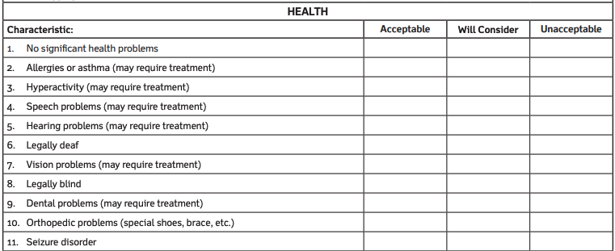
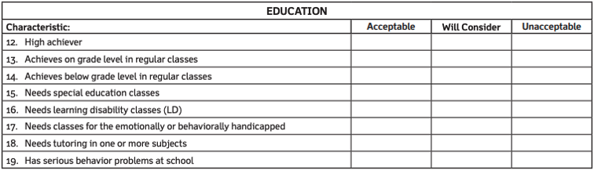
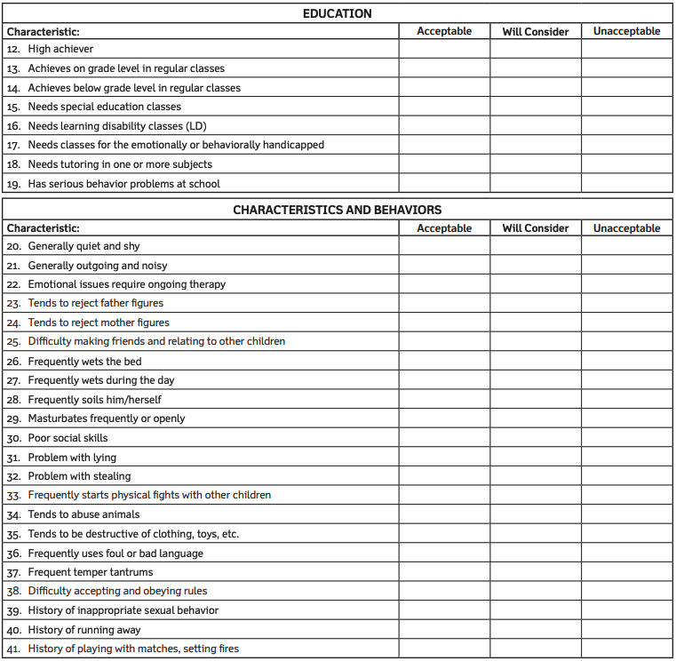
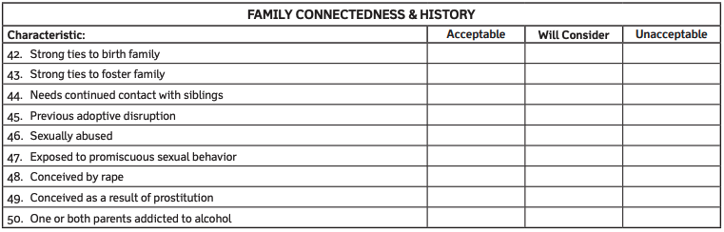

Do you have any additional considerations regarding youth that were not noted in the charts or questions above (IE: a mother/baby placement, immigrant youth, etc.): _______________________________________________

_____________________________________________________________________________________________

_____________________________________________________________________________________________

SIGNATURE:
To the best of my/our knowledge, the above information is true and accurate. I/we understand that failure to disclose true and accurate information may result in a termination of my application and/or contract process with Mazi Adoption and Family Services, and false statements are subject to the penalties of 18 PA C.S. §4904 relating to unsworn falsification to authorities. I/We understand that this application is not considered full disclosure and there will be further information collected throughout this process with Mazi Adoption and Family Services. I/We agree to submit any supporting documents requested of me for consideration.

______________________________________ ______________________________________ ____________
Applicant 1 Signature Applicant 2 Signature Date

------------------------------------------------------------------------------------------------------------------------------------------------------------------------------
FOR AGENCY USE ONLY

Mazi Adoption and Family Services Date
Acknowledgement of Receipt

Application Fee Received (if applicable) Date

Additional Comments:
________________________________________________________________________________________________________________________________________________________________________________________________
________________________________________________________________________________________________
________________________________________________________________________________________________

